Ansible and Node

* Create two instances one is ansible and other is node
* enable password authentication to yes I both machines.





* Restart the sshd service



* Check python version

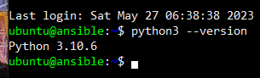

* Create a user called devops in both the machines

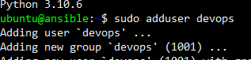

* Provide sudo permissions in both machines



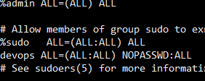

* Now exit from both the machines and login with devops user “ ssh devops@<public ip of machine>”

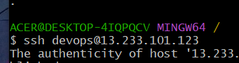

* Now , install ansible on ansible vm as devops user
* Follow the below commands in order to or create a file and execute all commands.

sudo apt update

sudo apt install software-properties-common -y

sudo add-apt-repository --yes --update ppa:ansible/ansible

sudo apt install ansible -y

* Check the Ansible version

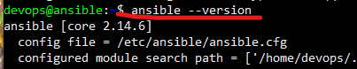

* Generate ssh-keygen in ansible devops user

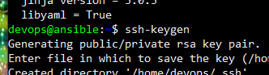

* In ansible machine do “ ssh-copy-id devops@<private ip of node>



* Now login to node from ansible machine “ssh <private ip of node>”





* Now exit from node machine in ansible
* Stay in ansible devops user
* Create an inventory folder
* Create a file in inventory with name hosts and add private ip of the node

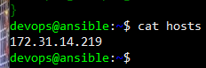

* Check connectivity by executing ansible -m ping -i hosts all

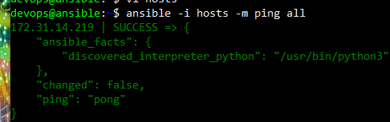

27-may-2023

* Create a folder inventory
* Create a file hosts in inventory



* create a folder playbooks
* create a file with name hello.yml

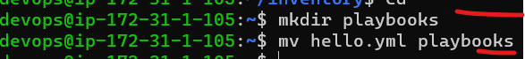

* Write a playbook for installing tree
* ---
* - name: tree
* hosts: all
* become: yes
* tasks:
* - name: install tree
* apt:
* name: tree
* state: present
* update_cache: true
* Now execute the file

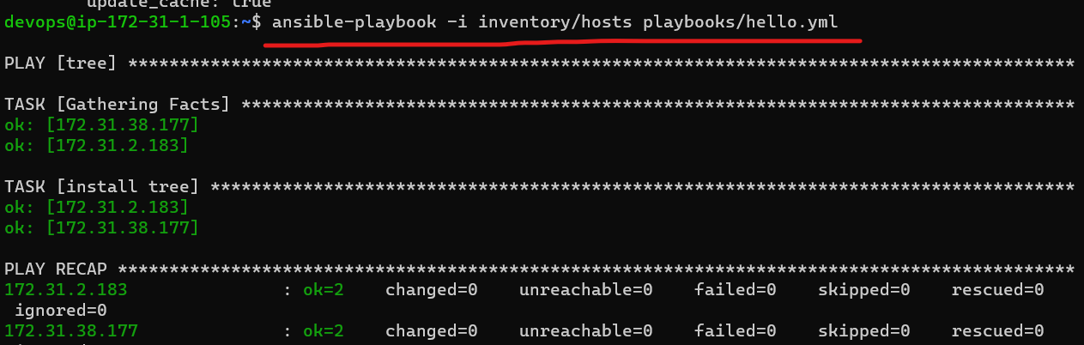

28/may/2023

**Installing lamp server on Ubuntu**

**Manual steps:**

sudo apt update

sudo apt install apache2 -y

sudo apt install php libapache2-mod-php php-mysql -y

# Create a file called as /var/www/html/info.php with below content

# <?php phpinfo(); ?>

sudo -i

echo '<?php phpinfo(); ?>' > /var/www/html/info.php

exit

sudo systemctl restart apache2

### Install lamp stack on Redhat 9

* sudo yum install httpd -y
* sudo systemctl enable httpd
* sudo systemctl start httpd
* sudo yum install php -y
* sudo -i
* echo '<?php phpinfo(); ?>' > /var/www/html/info.php
* exit
* sudo systemctl restart httpd

**31/may/23**

* to get data of a node



* to get data of any machine with filter for specific data

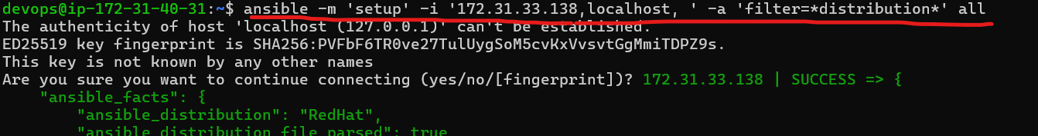

**Types of inventory:**

* static inventory: where we mention the list of nodes to connect to in some file
* dynamic inventory: where we mention some script/plugin which will dynamically find out the nodes to connect to
* Static inventory can be mentioned in two formats
  + ini
  + yaml (yet another markup language)

Collections

**Ansible Collections** are the format in which Ansible content like Modules, Roles, Playbooks and Plugin, etc. can be distributed to the Ansible users across Ansible community and Ansible users.

* To create an ansible collection

“ansible-galaxy collection init <name-you-want>”



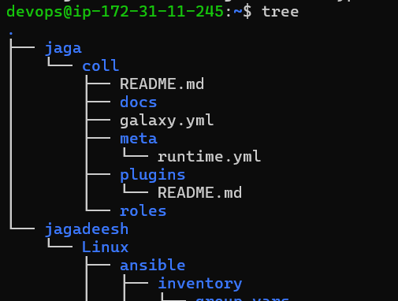

## Ansible Dynamic inventory

* Ansible supports dynamic inventory.
* Dynamic inventory can be acheived by
  + plugins
  + scripts

Ansible Vault:

Vault is used to encrypt data.

* Suppose create a file called data with some content in it.
* Now anyone can view the content it .

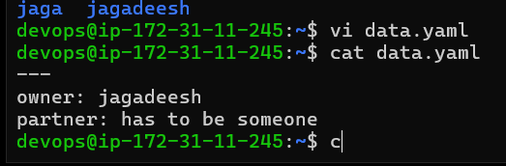

* Now create a vault and encrypt the data.
* To view the data first you should decrypt the file. To decrypt the file you need to enter the password of the vault.

